**Chapter 4**

**PRESENTATION, ANALYSIS AND INTERPRETATION OF DATA**

**Components of the Proposed System**

The researchers’ components of the proposed system are Arduino uno r3 for microcontroller board. AC relay module kit with outlet plug and wire for Arduino control of 220v AC load, 10 ohms and 100 ohms resistors, passive infrared sensor, a Grove LED display 16x2 IC2, GSM module, sim900 GPRS shield, wire, 5v power supply and Firefly Yellow Shield Antivirus and Germicidal UV Tube Set.

**System Implementation (Hardware)**

The model development stage consists stages of modeling, design and analysis. The researchers study different sanitation chamber, ultra violet chamber and sanitation device. The researchers ponder that the chamber must have the capability and strength to hold and sanitize objects with size of at least 50cm in height and width. After studying different sanitation chamber models and considering the researchers requirements, the researchers come up with the following model dimension.

*Insert model dimension image here*

The researcher’s requirement must have also that the device is mobile and have the capability to move around effortlessly. the device must also have the capability to smoothly insert objects inside the chamber. And to finish, the device must also be pleasant to look at and have the capability to blend to commercial sanitation chambers in market. The researchers come up with the following model design.

*Insert design image here*

Lastly, the design analysis data will be gathered from the survey to be conducted. Specifically, how does the automatic disinfection box be described in terms of satisfaction and cost.

**Materials and Specifications**

The following are the materials used for the disinfection box.

L- bracket or angle bar ¼ x 1 in size. Galvanized steel sheet with measurement of 4x8 in .9 thickness. Nylon caster wheels (swivel). Galvanized steel matting. ¼ thick clear glass. Stainless cabinet handle. Cylindrical hinges 3/8. Roller catches. Glass silicone sealant. Teks screw. Reflective Insulation foam. Rugby glue. Aerosol paint white and clear.

**Detailed Procedure**

Following the model dimensions, the angle bar or L-bracket are cut into lengths of 72cm (4), 84cm (4) and 54cm (4). The different lengths are welded into the shaped based on the model. The nylon caster wheels are then placed and welded to the based. L-bracket are cut into length, shaped and welded for the door frame. After installing the door frame, the roller catches are installed. Circuit chamber and sanitation chamber divider welded and installed. Galvanized steel sheet is cut and welded into the frame. The stainless cabinet handle is installed. The device is spray painted with white. After drying, a clear coat was applied. Galvanized mesh is added. Glass is installed to the door frame. The Firefly Yellow Shield Antivirus and Germicidal UV Tube Set are installed inside top section. Insulation foam is added to inner walls. The circuit is installed to the circuit chamber or box.

**Block Diagram**

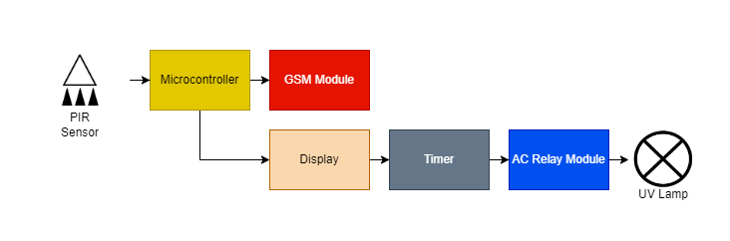

**flow chart**

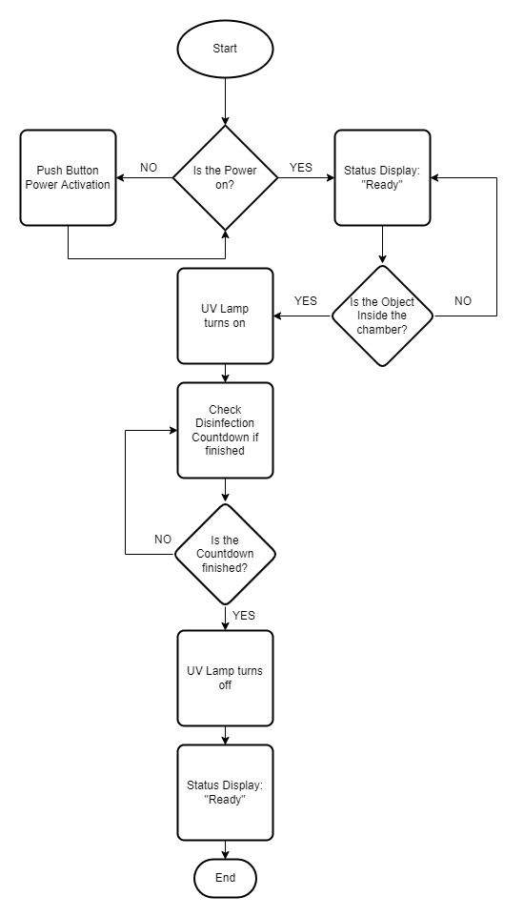

**Source Code/Software**

**Component Analysis**

The researchers’ components of the proposed system are Arduino uno r3 for microcontroller board. AC relay module kit with outlet plug and wire for Arduino control of 220v AC load, 10 ohms and 100 ohms resistors, passive infrared sensor, a Grove LED display 16x2 IC2, GSM module, sim900 GPRS shield, wire, 5v power supply and Firefly Yellow Shield Antivirus and Germicidal UV Tube Set.

Arduino Uno R3 is a 14 input/output pinned microcontroller which has a 16-Megahertz ceramic resonator, USB connection, a power jack, an ICSP header and a reset button. This is a microcontroller that can be programmed and as such, can be the only microcontroller you will ever need in creating complicated systems.

Arduino Uno can only handle up to 5 volts and can malfunction when applied at a higher voltage, much more when using 220 AC volts into it. The AC Relay module kit helps the microcontroller to handle up to said voltage that is in the description of the module. In the module used in the project, the researchers specifically used a 220v AC load.

Resistors are static components that help regulate the current running in a circuit. The higher the resistance(ohms), the lesser the current(amp). In the project, the researchers specifically used 10 ohms and 100 ohms values of resistors.

Passive Infrared Sensors or PIR Sensors is used to detect an object that is in front of it and act as a switch to a circuit. It activates the circuit when the object is detected by the infrared. This is commonly used in automatically triggered lighting devices and protection systems. In the project, the researchers used it as a detector for the object or item placed inside the chamber to automatically start the disinfection process.

LED Displays are displays that are commercially used in the market because of their efficiency and low-energy consumption. These displays are made up of a series of LED panels which contain LEDs that can be used in a variety of ways from providing light to sending a message. The researchers used a Grove, 16x2 LED display which can be programmed with the use of Arduino Uno and is used to display the status of the disinfection process.

GSM (Global System for Mobile Communications) Module is a chip that can be used to provide the option to send SMS (short messages service) messages in a system. This chip has an antenna to receive and send out transmissions and a slot for the sim card which will be used to send out messages to other devices. The sim900 GPRS shield is the specific model used by the researchers. Despite the small size of the model, this packs many features and is one of the latest models.

The circuit created by the researchers is connected by copper wires. Copper wires are most commonly used in circuits for its conductivity and these wires are covered by rubber for insulation.

Power supplies are components that supply power to at least one load. This is used to provide and regulate a consistent value of current to a load to avoid any inconsistency to the load that can cause complications and malfunctions for the load. The researchers used specifically a 5v power supply that is used to supply power to the Arduino Uno.

UV lights are lights that are capable of disinfecting surfaces within a prolonged period of time under a specific range of intensities. The researchers used Firefly Yellow Shield Antivirus and Germicidal UV Tube Set which has an intensity of 254 nm, operates at a 230 V at 60 Hz, and covers the range of 15 to 20 square meters.

**Schematic Diagram**

**Fabrication of the Device**

**Functionality Testing**

**Survey / Results and Discussion**

**Experiment procedure**

***Disinfecting using UV Light***

Prepare 3 pencils that are equally exposed to normal condition. Afterwards, prepare 3 agar plates. Place the pencil inside the biosafety cabinet and expose it to desire duration of time. Now, place the prepared agar plate inside the biosafety cabinet. Using the sterilised cotton buds, swab the surface of the pencil.Next,open the agar plate and swab the cotton buds in it. Lastly, secure the plate using cling wrap. the procesure should be done with the remaining pencils. For the positive control, swab the pencils before it was exposed to UV light and transfer the swab into the agar plate. For the negative control, just leave an empty agar plate.

***Preparation of Agar plates***

Sterilize the petri plates using the pressure cooker.

Create a 500 mL nutrient agar solution by dissolving the premixed nutrient agar into boiling water.

Mix continuously until the nutrient agar was fully dissolved.

In a sterile environment, pour 50 mL on each petri dish.

Cover the plates well and avoid long exposure to air.

Let it cool and settle.

effect of ultraviolet radiation on microbial growth of microorganisms using automatic disinfection box utilizing Arduino microcontroller